

**Operating System**

**Spring 2022**

**Project: Icecream Factory Problem**

**Introduction:**

This project creates a simulation of an ice cream shop where multiple customers are entertained with preventing race condition.

**Approach:**

In this project we have implemented Ice cream factory using Multi-Threading, in which component of ice creams are a made by Thread at each counter. These Threads will be executing concurrently with other Threads It consist of two components Client and Server implemented on Inter process communication with shared memory. Firstly Server will allocate the shared memory with address to which our Ice cream (Thread) will do function. Then it will write data on thread by allocating flavors to our ice cream and then it will call other processor. After all it will detach and DE-allocate the shared memory segments of our Ice-cream or Thread of client and server. While in the Client shared memory segments will be allocated and attached to our ice cream components or Threads. Local semaphore will be used there .It will also show as Ice cream or thread has been successfully created.

Order of ice cream will arrived at first counters then sequence of counter will accomplish the order by providing different flavors for their ice-creams. They will be served by multiple flavors including in critical section and after that it will wait for 5 sec so that ice cream flavors will be assign to ice cream without any hurdle. After completely filling, Ice cream orders will be ready to distribute.

**C code implementation:**

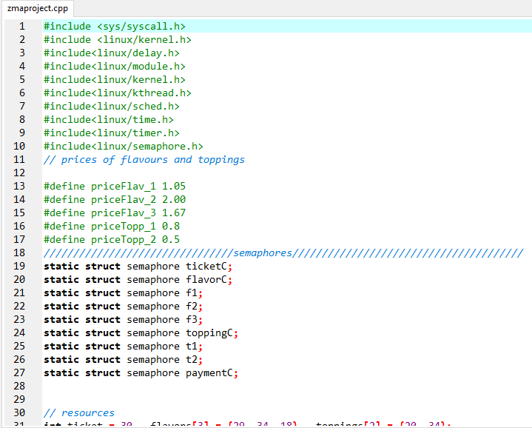

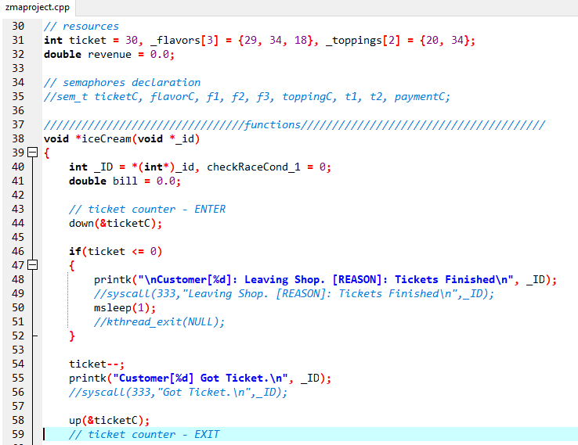

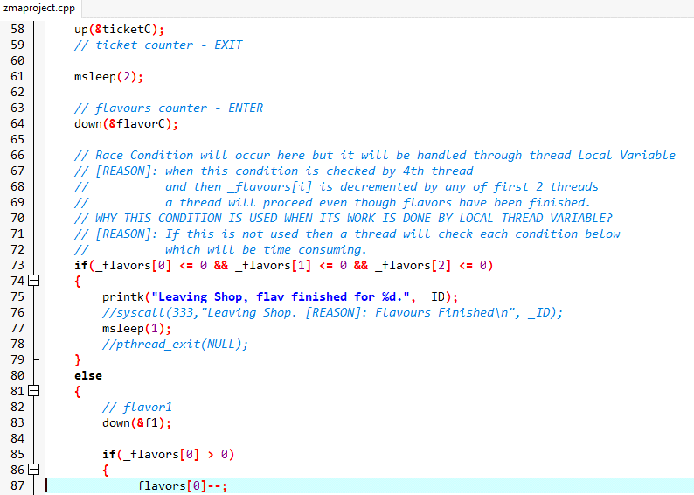

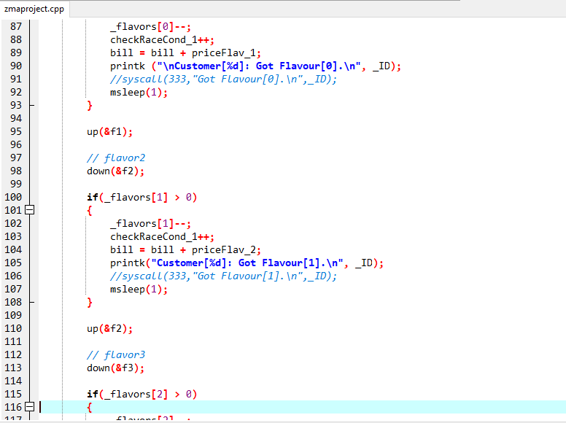

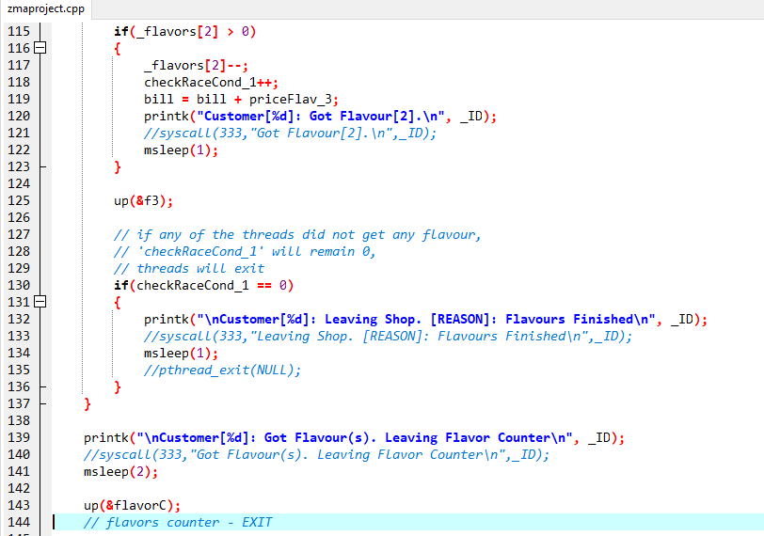

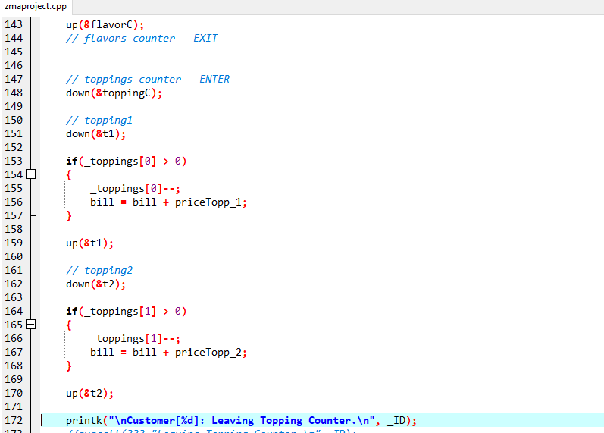

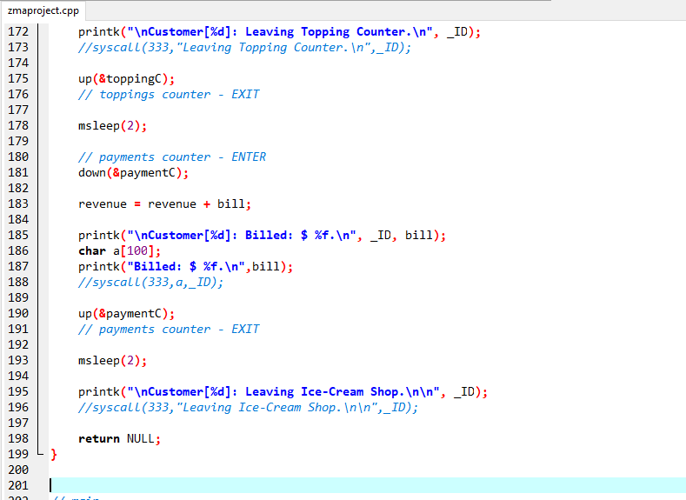

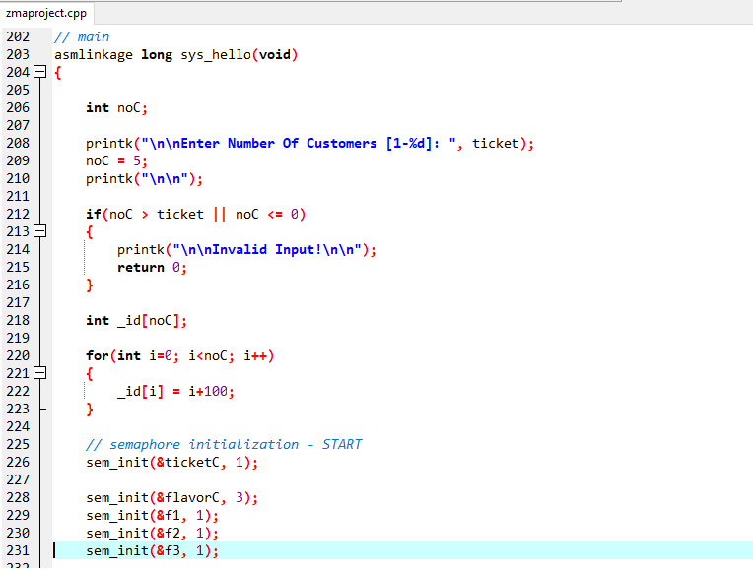

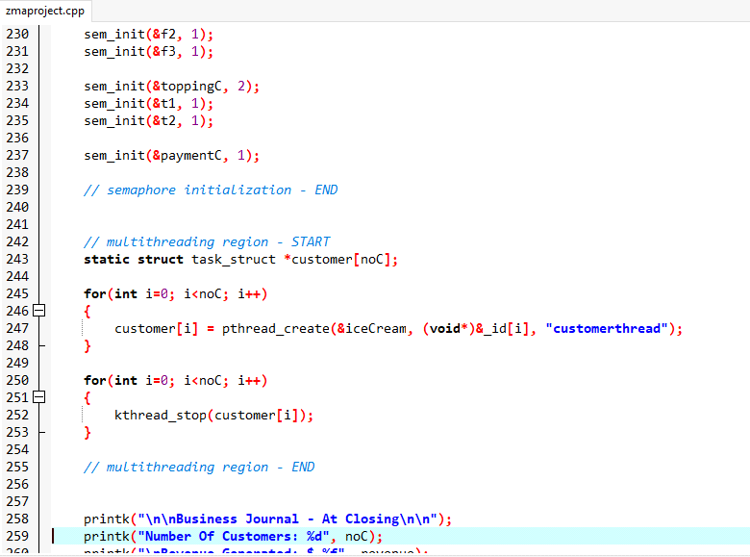

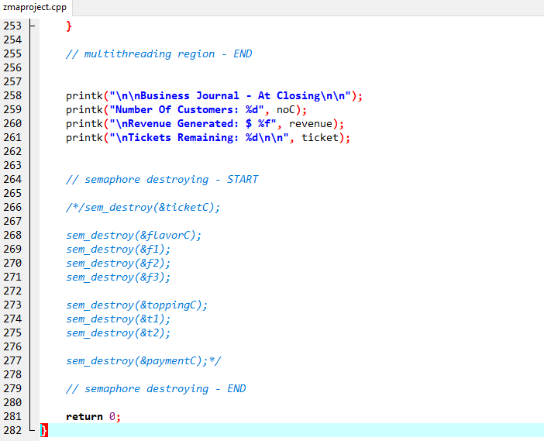

**Kernel implementation:**

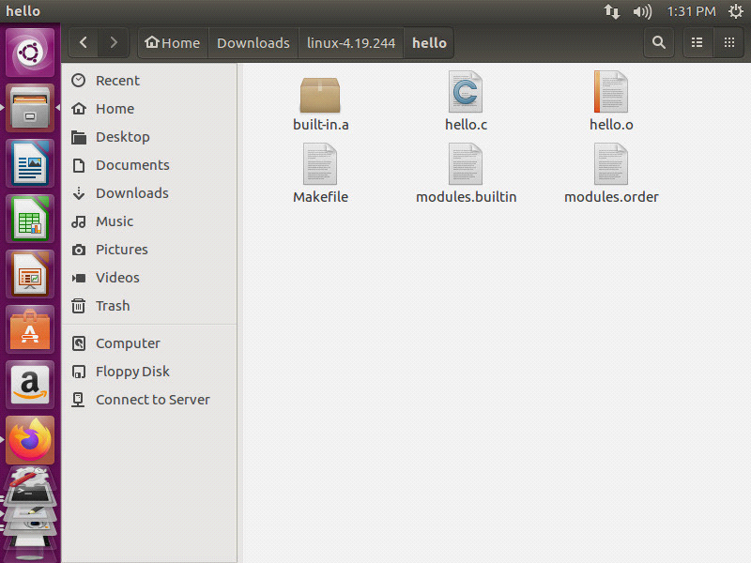

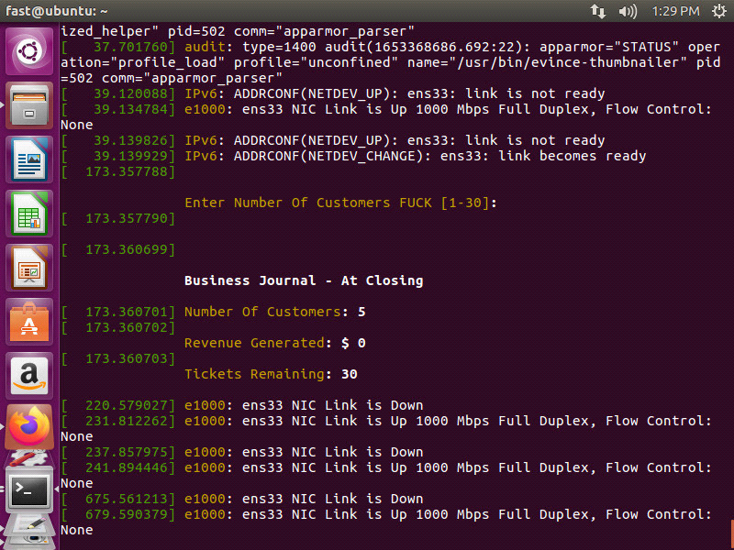

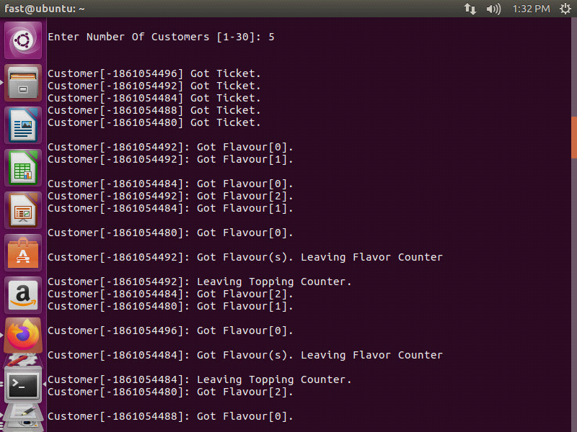

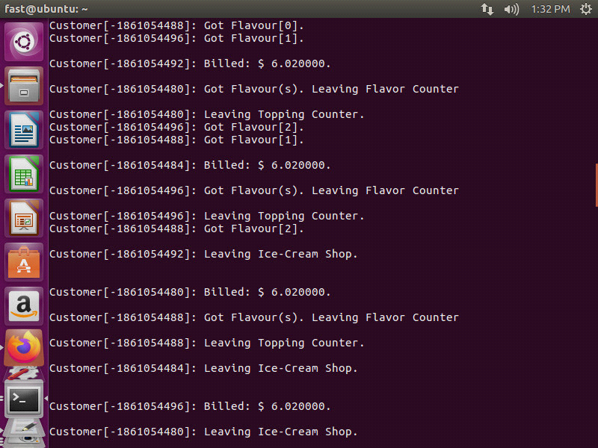

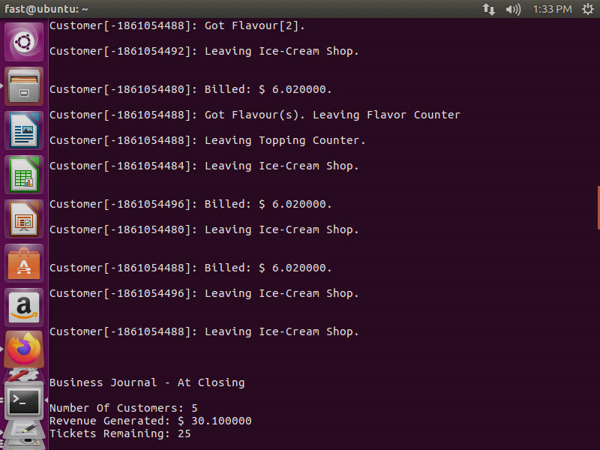

**Conclusion:**

The C code and kernel works perfectly fine as we were expecting it to be.The Output is upto our requirement.Number of customers,our revenue and the remaining tickets in the shop are displayed at the end of the output.This is what we wanted.